Minesweepers Competition Technical Report
Assiut Robotics

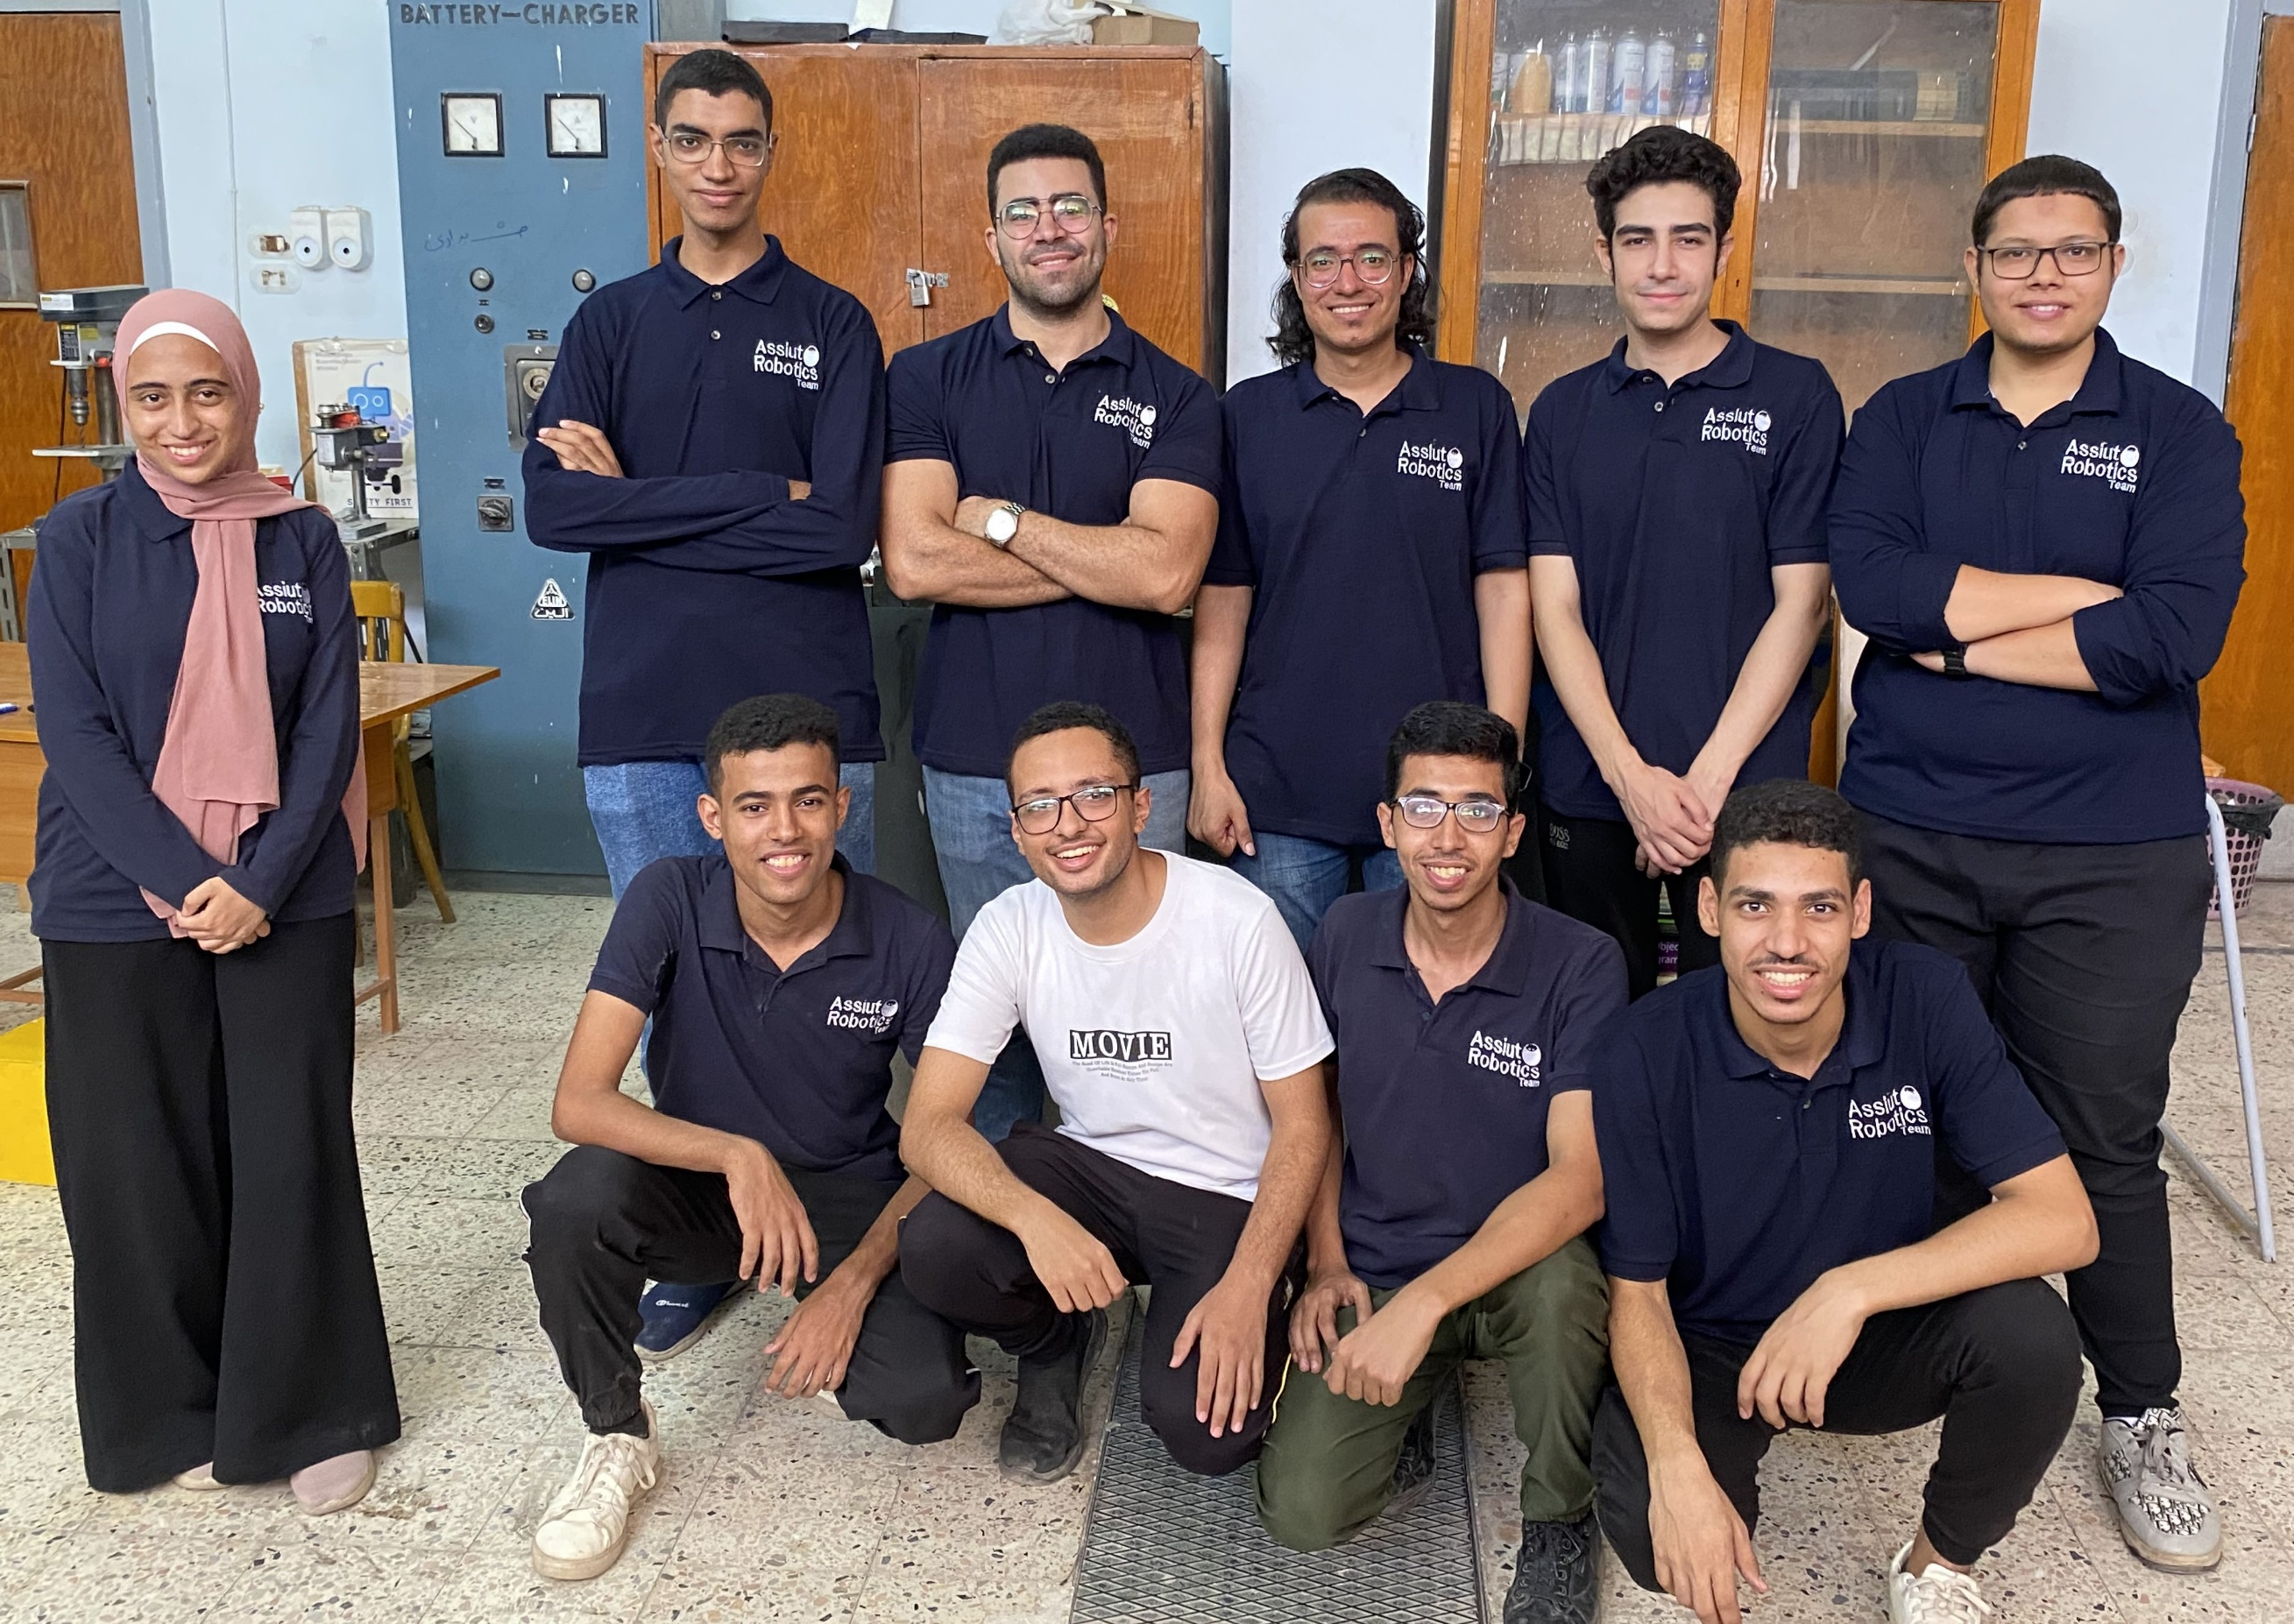

Assiut University
Eng. Sayed Khader
Academia
Egypt - Assiut

Abstract [Overview about robot/system] [250 words] (5 Points)
In aiming for a landmine-free world, we must have a well-designed and carefully controlled system. This is what we are committed to achieving with our minesweeper this year. Our minesweeper is controlled by a Raspberry Pi running a ROS package composed of multiple nodes, topics, and services. It can scan a minefield, detect both surface and underground mines, generate a map locating the detected mines, and remove surface mines from the field. The system consists of ROS nodes, each responsible for a specific task, which communicate with one another to ensure the system works as expected.
These are the missions our robot is capable of performing. But how is it able to accomplish them? How does the design contribute to this? What different mechanisms have been employed? How do we control the entire system to achieve the desired output? These are the questions we will answer in detail in this report.
Describe your mechanical design and locomotion system [250 words + image] (10 Points)
This year, we decided to make the robot lightweight without compromising its structure. To achieve this, we used high-density MDF wood sheets. Regarding the structure of the robot: the base has a thickness of 8 mm and is covered with 4 mm sheets. We also used acrylic for both the metal detector and the gripper, which provides high performance while optimizing motor efficiency. Speaking of motors, we should briefly specify their details. We used four DC motors with gearboxes, each generating about 70 RPM and 27 kg/cm of torque. Additionally, the robot is equipped with 20 cm diameter wheels.
This describes the latest version of the design, but what about the initial designs? The main difference between the initial and final designs is that we aimed for a more compact structure, which supports the goal of reducing weight while providing suitable space for each component inside the robot. We also included a separate compartment for the collected mines, keeping them away from the electrical components.
This is how we progressed towards our goal of creating a mechanical design that aids in achieving the primary missions of our Minesweeper."
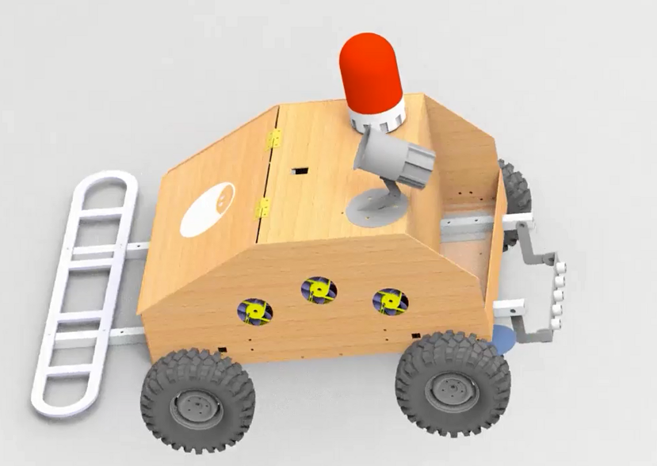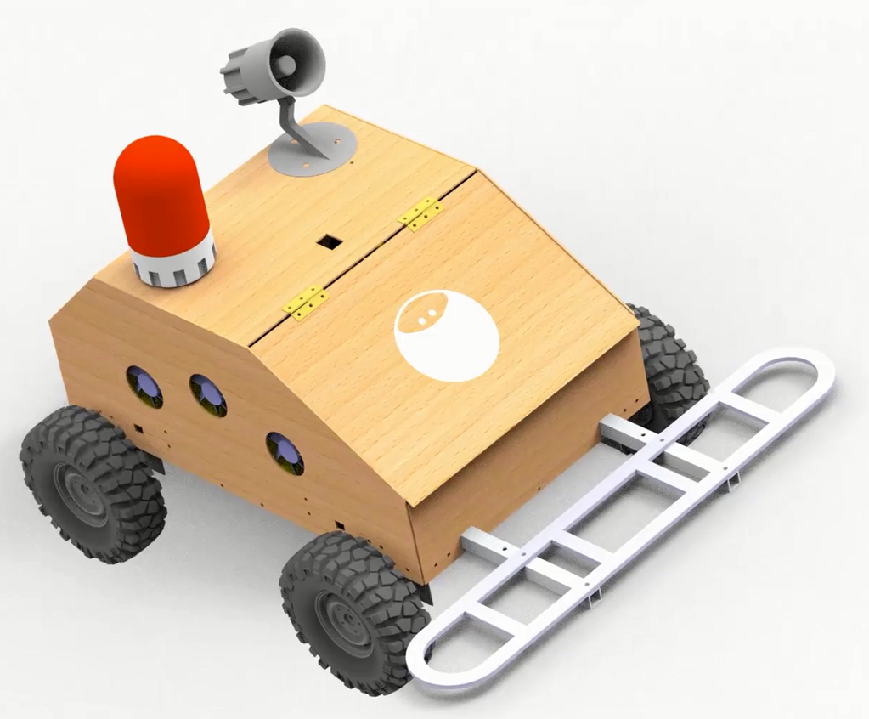
Figure 1_Our Minesweeper Robot

Describe the landmine disposal and marking mechanisms [250 words] (10 points)
To detect both hidden and visible mines, the robot must be equipped with mechanical parts that work through specific mechanisms, providing features beyond the electrical and control systems. For these tasks, we chose the following gripper mechanism:
For disposing of surface mines, we designed a tailgate mechanism that operates using two DC motors with magnets at the end and two limit switches at the top and bottom of the robot, which signal the tailgate when to stop while rising or falling. When a surface mine is detected, the tailgate mechanism activates, holds the mine using electromagnets, lifts it up, and drops it into the mine box on the robot. The tailgate then returns to its initial position, ready for the next surface mine.
We found this mechanism to be efficient for completing the task in the simplest way possible. We hope.
Figure 2_ removing mine mechanism using electric magnets.

Describe sensors and how can it detect landmines? [250 words] (10 Point
Our robot's main localization plan is based on getting odometry data from rotary encoder placed in the middle of the frame. But rotary encoders are not enough, as they leave errors behind. So, we used IMU to get odometry data, and we added up the data coming from encoders and IMU together, we used sensor fusion to output less faulty data. For detecting mines, we are required to determine if the mine is buried or on surface, So we used a metal detector and several proximity sensors pointing downwards, if a mine is detected the sensors will check to see if there is an object underneath, so we can determine if the mine is on the surface, then the magnets pick it up and other proximity sensors come in to confirm that it has been picked up.
Describe how to provide the map of detected mines? [250 words] (10 Points)
First of all, we need get a pure robot position. We are planning to use two rotary encoders to obtain the robot odometry data then fusion these data with IMU sensor which has a 3-axis gyroscope and accelerometer.
Now once the metal detector finds a mine it will take the position and mark at the map immediately.
We are planning to provide a real time map at Gazebo simulator which displays robot position and mine’s locations.

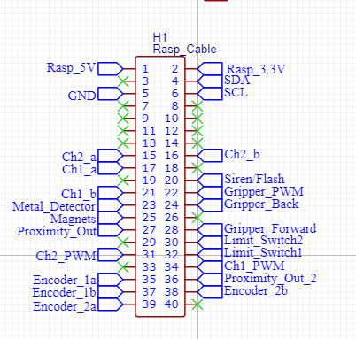
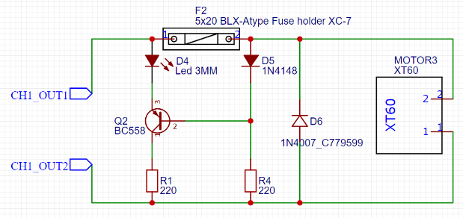
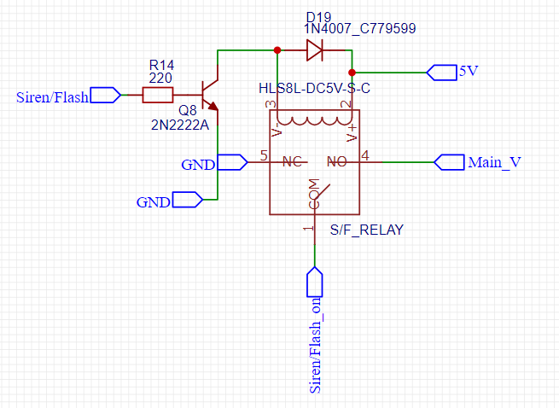
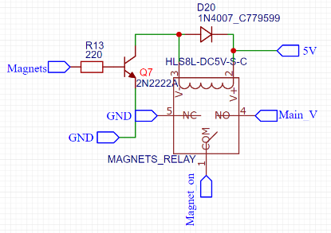
Describe your electronic circuit/control system/platform used [Teleoperated/Autonomous] [250 words + image] (10 Points)
Figure 3_ protection circuit for motors.
Figure 4_ circuit for Siren and flash.
Figure 5_Pinout of raspberry pi.
Our minesweeper robot is equipped with a Raspberry Pi 4 as the central control unit, orchestrating both teleoperated and autonomous functions. The system integrates a variety of sensors and actuators to detect and safely remove mines.
• Proximity Sensors:
- We employ five proximity sensors dedicated to detecting unhidden mines. Sensors ‘s signals are processed through an OR gate, which sends a collective signal to the Raspberry Pi. Upon detecting a mine, the Raspberry Pi activates the siren and flash circuit, signaling successful detection.
• Magnets and Metal Detector:
- The magnets are designed to pick up unhidden mines and deposit them in a secure container. The metal detector, on the other hand, identifies hidden mines and sends signals to the Raspberry Pi. These signals are crucial for localization, mapping, and triggering the siren and flash circuit for alerting.
• Motors and Motor Drivers:
- The robot's movement is powered by four main motors, controlled by a 2-channel motor driver, while the gripper mechanism is operated by two additional motors, managed by a 1-channel motor driver. Each motor is protected by an indication circuit that limits current, preventing damage.
• Control System:
- The Raspberry Pi 4 receives input from the sensors, processes the data, and controls the motors and actuators accordingly. This setup allows for precise movement and mine detection, ensuring safe and effective operation in both teleoperated and autonomous modes.
This integrated control system ensures the robot performs its tasks efficiently, with real-time responses to sensor inputs.

Put your plan to navigate the whole arena [250 words] (10 Points)
To navigate the minefield in Minesweeper, we’ll use a joystick to control the robot, equipped with a camera to detect mine positions based on the grid intersections marked by numbers and letters on the field walls. We’ll start by moving the robot in a systematic grid pattern, scanning each section with the metal detector and proximity sensors to identify mines. The robot will mark detected mines on a digital map. We’ll prioritize clear paths and avoid marked areas, adjusting our route dynamically based on real-time sensor data. This method ensures thorough coverage and minimizes the risk of triggering mines, allowing us to safely navigate the entire arena. Additionally, we’ll implement a backtracking algorithm to revisit and clear any previously inaccessible areas once new paths are identified, ensuring complete and safe navigation.
To enhance our strategy, we’ll also incorporate a decision-making algorithm that evaluates the safest and most efficient path based on the detected mines and the remaining unexplored areas. The robot will use this algorithm to decide whether to continue in a straight line, turn, or backtrack. This approach will help in optimizing the navigation process, reducing the time taken to cover the entire field. we’ll maintain constant communication with the robot to receive real-time updates on its position and the status of the mine detection. This will allow us to make immediate adjustments to our plan if necessary. By combining systematic scanning, dynamic route adjustment, backtracking, and decision-making algorithms, we can ensure a comprehensive and safe navigation of the minefield.
How to face the rough environment and the high heat? [250 words] (5 Points)
In our design, we selected a huge off-road wheel (22cm diameter and 10cm width). This wheels are designed especially for rough environment such soft sand, sand or rockets or grass. In addition, we decided to cover this wheels with a layer of a rubber to make sure that the wheel has enough friction to avoid slipping in any environment types.
In addition, facing rough environment needs extremely high torque at low and high RPM. So, we selected a motor for each wheel with a gearbox to generate high torque. Actually, every single motor with a gearbox can carry about 18 Kg and this is quite enough for this robot.
To deal with heat, we made the robot frame out of wood, made ventilation holes, made a special fixation for electrical components and used cooling fans to make sure that these components won’t damage due to high heat conditions.

Put your Video YouTube link here:
https://youtu.be/dL5ubC7n4h4

